DATABASE WEEK02

a
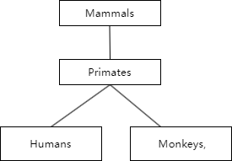
b
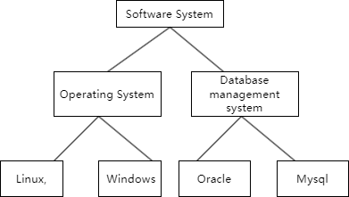

2.
a. Entity：In the ER model, an entity is a distinct object or concept in the real world that can be identified and described. For example, a person, a car, or a book can be entities. Entities have attributes that describe their characteristics.
b. Entity type：An entity type is a category or class of entities that share the same set of attributes. For instance, “student” is an entity type that has attributes like name, age, and student ID. All students in a database belong to the entity type “student”.
c. Entity instance：An entity instance is a specific occurrence or individual example of an entity type. For example, if “student” is an entity type, then a particular student named John with an age of 20 and a specific student ID is an entity instance.
d. Optional：In the context of relationships between entities, if a relationship is optional, it means that an entity does not necessarily have to be related to another entity. For example, a student may or may not have a scholarship. The scholarship relationship is optional for the student entity.
e. Mandatory：If a relationship is mandatory, it means that an entity must be related to another entity. For example, every employee must have a department. The relationship between employee and department is mandatory.
f. Cardinality：Cardinality describes the number of instances of one entity that can be associated with the number of instances of another entity. For example, a one-to-one cardinality means that one instance of entity A is associated with exactly one instance of entity B. A one-to-many cardinality means that one instance of entity A can be associated with many instances of entity B.

3.
Definition of data model:A data model is an abstract description of the characteristics of data in the real world. It defines the structure, relationships, constraints, and operation rules of data. For example, the table structure in a relational database is a kind of data model, which clearly defines the fields, data types, and the relationship between tables.
Three reasons why data modelling is important:
1)Improve data understanding and communication efficiency:
Data modeling provides a clear structure and definition for data, enabling different people (such as developers, data analysts, business people, etc.) to better understand the meaning, source, and usage of data.
It serves as a common language to promote communication and collaboration among team
members and reduce errors and misunderstandings caused by inconsistent understanding of data.
For example, in an enterprise, business people can understand which data is available and how to use this data to support decision-making through the data model, while developers can design database structures and applications according to the data model.
- Ensure data quality and consistency:
Data models can define constraints on data, such as data types, value ranges, required fields, etc., thereby ensuring data quality and consistency.
When data is input or updated, the system can validate according to the constraints of the data model to prevent incorrect or unregulated data from entering the database.
For example, in a customer relationship management system, the data model can stipulate that the customer's name cannot be empty and the phone number must be in a valid format, which can ensure the accuracy and integrity of the data.
- Support system design and development:
Data models are the basis of system design and provide guidance for database design, application development, and data analysis.
Developers can design database structures, write query statements, and develop applications according to the data model to ensure that the system can effectively store and process data.
At the same time, data models can also help developers better understand business requirements and improve the maintainability and scalability of the system.
For example, in an e-commerce system, the data model can include entities such as products, orders, and customers, as well as their relationships. Developers can design database table structures and business logic according to this model to implement the functions of the system.

4.
The diagram represents a firm which has multiple branches. Each branch contains one or more departments. Departments are made up of employees. An employee can only belong to one department. A department must have at least one employee. An employee may manage at most one department and a department must be managed by exactly one employee. Additionally, employees can participate in multiple projects and a project must have at least one employee.
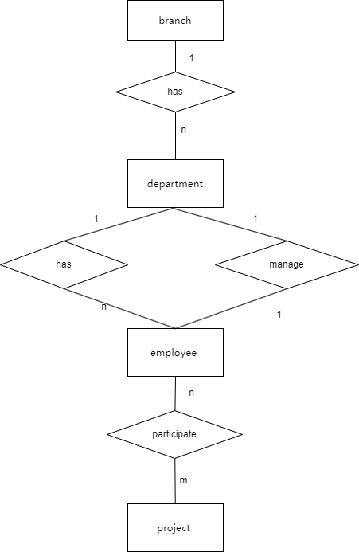

5.
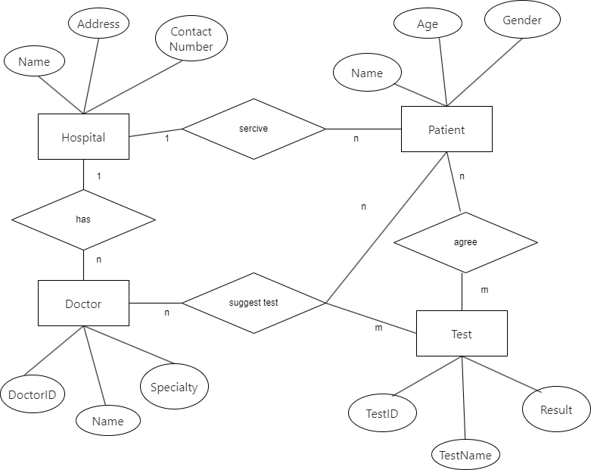

6.
